Welcome to the MA in Education course (part time)
We are delighted you are going to join us for our Master’s in Education course in September 2023. Please read the following carefully as it contains important information for your course. This information, plus additional videos to welcome you to the course is also available at our welcome site so please do explore more resources here:
https://bcumaed.weebly.com/

Induction
There will be an induction evening on Thursday 14th September from 5-7 online on MS Teams. A link will be sent to you. There will also be a number of induction videos shared to support you to use the BCU services successfully. There is a tutor team welcome video here for all new starters: https://youtu.be/tzmlI7A_2I8
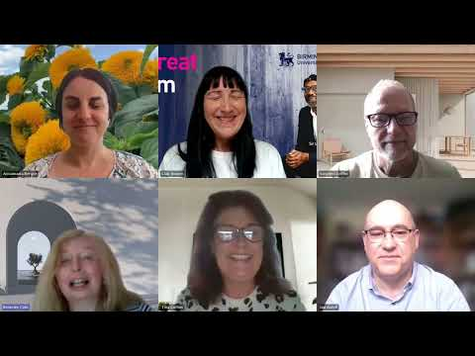

Pre-course reading
We want you to be as successful as possible on the course and one of the ways you can be prepared is by immersing yourself in reading about educational issues. Please take some time to explore some of the suggestions in the pre-course reading suggestions booklet. Tutors may well refer to these readings during the year and we will make use of them during induction. I hope they stimulate some interesting thinking and discussion about education.
Your modules
Your course: bringing credits for prior learning
A Master’s degree is equivalent to 180 credits. Some of you will be studying the whole 180 credits with us and some of you are bringing credits with you towards the degree. If you wish to bring credits from previous relevant study at level 7, it is essential that you have let our administrator Fahiza Hanif know this IN ADVANCE OF ENROLMENT and have completed the correct form. Please contact her if you still want to transfer credits Fahiza.hanif@bcu.ac.uk and request a form from HELS.rpl@bcu.ac.uk .
Please note that some funding and loans stipulate you must study 180 credits and cannot transfer credits so please be mindful of the terms and conditions. For more information the updated page about RPL (recognition of prior learning) is here: https://www.bcu.ac.uk/education-and-social-work/about-us/rpl .

Your course: choosing your modules
How many modules you choose will depend on whether you are joining the course with previous credits.
Choose below the description that describes your situation:
- You are studying a full 180 credits:
You will need to take Introduction to Masters level study module plus Research Methods plus dissertation (these are core modules). You then have the choice of 4 additional modules. These should be spread over the year. OR
- You are studying 120 credits:
You will need to take Research Methods and dissertation (these are core modules). You then have the choice of 2 modules. It makes sense to take these in semesters 1 and 2.

Selecting your modules:
Check out our site using the link https://bcumaed.weebly.com/
The September Starters tile will provide links to module timetables and readings https://bcumaed.weebly.com/part-time-starters.html . Module guides and videos are available here https://bcumaed.weebly.com/modules.html explaining the content and assessment of each of our modules. This will help you to choose the modules most suited to your interests if you have accepted your offer and intend to start in September. Please complete your module choices using this direct link: https://forms.office.com/e/inCBzk8mC3 , preferably before Friday 15th September at 10am.
You must make sure that you will have achieved 180 credits by the completion of your course. Your own personal timetable will then be generated on the basis of these choices. Please make sure you have made your choice prior to enrolment.

Enrolment
Further details regarding enrolment will be sent to you. It will take place online.
Please do not hesitate to be in touch if there is anything we can help you with prior to starting the course. Your key contacts are Dr Stephen Griffin and Dr Tina Collins (course leads) Stephen.Griffin@bcu.ac.uk Tina.Collins@bcu.ac.uk and Fahiza Hanif (course administrator): fahiza.hanif@bcu.ac.uk
We are looking forward to meeting you in September!
The MA Team

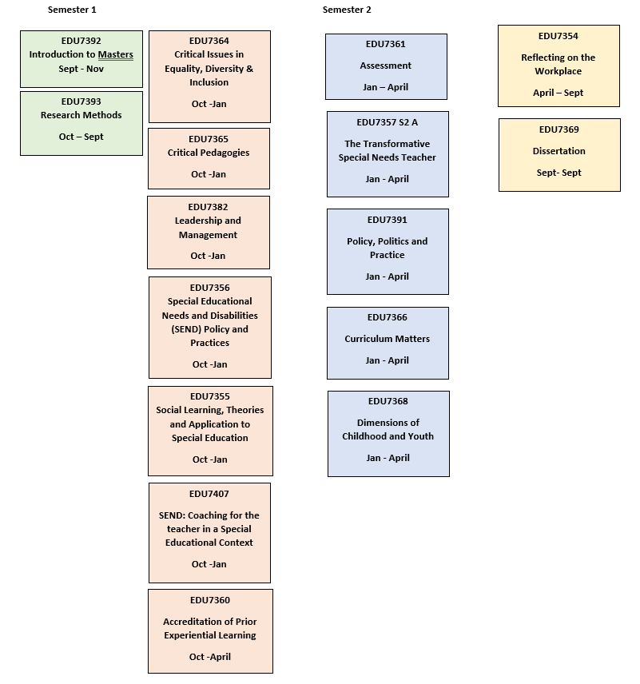
Detailed timetabling will be available on your MySRS student portal. Please complete your module choices using this direct link: https://forms.office.com/e/XS2ges8YWt . preferably before Friday 15th September. This gives you time during induction week to make your selections.

